BetterHelp is one of the best online therapy networks. It provides services for individuals, couples, and teens, and it connects you with a professional, licensed, and vetted counselors that you can trust to help you deal with your mental issues including depression, anxiety, relationships, trauma, grief, and more. This network has 9317 licensed therapists that are all ready to help you.
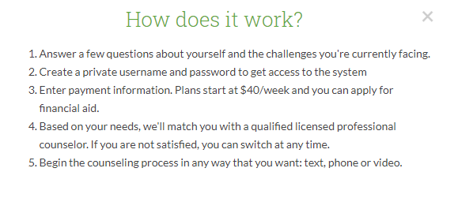

If you have a question, concern, idea, feedback, or problem, please email contact@betterhelp.com, or visit https://www.betterhelp.com.

