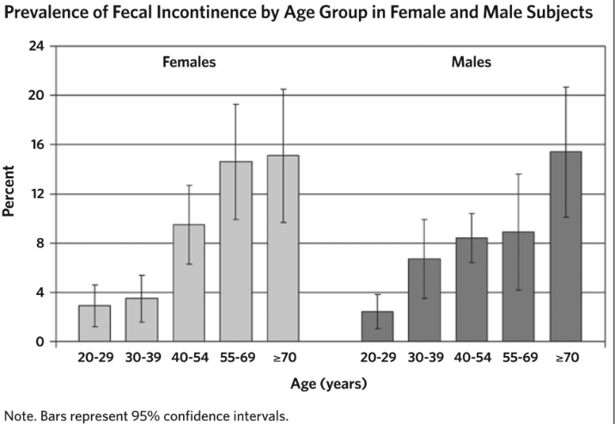
Fecal Incontinence, FI is defined as the person’s inability to control bowel movements causing the stools to leak unexpectedly from the rectum. It happens to both adults and children, but it is more common among older adults. Some persons living with scleroderma can experience fecal incontinence and will need to be seen by a Gastrologist.
FI is not considered a serious health problem, but it can interfere with your daily life and prevent you from many social activities.
Types of Fecal Incontinence
- Urge incontinence means that people with this condition are unable to stop the urge to defecate, which comes on so suddenly that they do not make it to the toilet in time.
- Passive incontinence occurs in people who are not aware of the need to pass stool.

Causes of Fecal Incontinence
- The damage of the muscles around the anus.
- Vaginal childbirth that can damage the anal sphincters or their nerves.
- Anal surgery.
- Diarrhea
- Severe constipation
- Inflammatory bowel disease
- Nerve damage due to diabetes, scleroderma, spinal cord injury, and others.
- Radiation damage to the rectum that can happen after receiving a treatment for prostate cancer, for example.
- Cognitive impairment in children and adults.
Prevention
- Reduce constipation by exercising daily and eating food that is high in fibers.
- Control diarrhea by avoiding the causes of it.
- Avoid straining. Straining during bowel movements can eventually weaken anal sphincter muscles or damage nerves, possibly leading to fecal incontinence.
Treatment
Fecal Incontinence is usually treatable and cured completely in many cases, and the treatment includes:
- Changes in diet that involves eating a good amount of fibers, avoiding caffeine to prevent diarrhea, and drinking a lot of water to prevent constipation.

- Medications like Imodium, Lomotil, and Hyoscyamine can be used to reduce the number of bowel movements and to urge them.

- Exercising daily and focusing on those that can strength the pelvic muscles, for example, Kegel exercise.

- (Kegel exercises are simple clench- and- release exercises that you can do to strengthen the muscles of your pelvic floor, which is the area between your hips).

- Promoting bowel training by scheduling bowel movements at the same time each day to help prevent accidents in between.

- Anal surgery to tighten the anal muscles together.

- Biofeedback is a medical technique that makes you learn how to use your mind to control your bodily functions with the help of sensors.

- Solesta gel therapy that was approved by FDA in 2011, and it helps increasing the amount of rectal tissue and treat FI by injecting this gel into the wall of the anus.

Resources for Fecal Incontinence
Find a doctor by clicking on one of these provided links:
https://amwell.com/landing.htm?utm_medium=affiliate&%243p=a_hasoffers&offer_id=108&~click_id=10295999c7e1238c2f6c76001b2b6d&~cost_currency=USD&~cost_value=0.00&~secondary_publisher=amwell_hl_bot_broadcare_803&~channel=Red%20Ventures&~campaign=%2Fhealth%2Fbowel-incontinence&~ad_set_name=83418170&~ad_name=&~keyword=&_branch_match_id=634424375891633591&utm_source=Red%20Ventures&utm_campaign=%2Fhealth%2Fbowel-incontinence

https://doctor.webmd.com/find-a-doctor/condition/gastroesophageal-reflux-disease-gerd/michigan

Use any of the provided applications to help you controlling your condition
- Squeezy is the multi-award-winning app supporting people with their pelvic floor muscle exercise programs.

- Pelvic floor list app helps people with bladder and bowel problems by educating them, increasing their awareness, advising them professionally, and providing them with many pelvic floor exercises to strengthen their muscles.

- 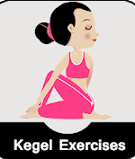Kegel exercises app can help prevent or control urinary and bowel incontinence and other pelvic muscle problems. It provides users with various Kegel exercise videos, and it teaches them how to do it in the right way.

- Sit or squat is developed to help people find the nearest public toilet. It is free and can be used worldwide.

- Kegel training PFM exercises app gives you 10 different exercises to practice Kegels. If people are prone to forget, this app can remind them daily.

- Tat is an iPhone app with 6 basic and 6 advanced pelvic floor music training sessions.

- PoopLog helps people to track their bowel movements and a range of accompanying details that suit their needs. It also gives them a chance to review their history as an expandable list, browse charts, totals, and trends, and create, save, and share customized reports for their doctor to review.

- Cara: Food, Mood, Poop Tracker monitors people’s digestive health to learn more about the connection between their mind, gut, nutrition, and overall well-being. Cara lets people track food, stress, poop, tummy pain, and individual factors to create a personalized health diary.

- Fodmap helper hjelps those with digestive problems to access comprehensive list that makes finding low or high FODMAP foods easier.

- Fecal incontinence pads or bowel incontinence pads are designed for those that suffer from Accidental Bowel Leakage and are looking for a product that absorbs leaks and odors while being discreet. Fecal or bowel incontinence pads are specifically shaped to fit in and around the buttocks and are designed to absorb liquids and hold the stool in place.

Before you decide what product is right for you, here are few things to keep in mind:
- Latex Allergy: If you have an allergy to certain types of materials such as latex, make sure you read about what the product is made of before you experience a skin irritation, which could worsen the condition.
- Absorbency Level: Make sure you choose the right absorbency level. A pad that is for light bowel leakage will not be sufficient for someone with heavy bowel incontinence.
- Odor Control: Look for a product that has odor control. When odors are neutralized, you are more apt to confidently get through your day without embarrassing odors.
- Proper Fit: Choose a product that securely fits and will absorb all leakage. A poorly fitting incontinence product will not contain the fluids and you'll risk leaking out of the product and soil your clothing.
- Added Protection: It might be a good idea to also keep in mind that you may want to protect your bed or any other surfaces with an under pad.

Get pads for bowel incontinence from:
- Pharmacies
- Some hospitals and doctors’ clinics that provide free pads.
- Shop around on the internet to get some good deals.
- Shop directly from the manufacturer.
- Shop from Incontinence supermarkets that can also provide you with free pads.

https://www.nhs.uk/conditions/bowel-incontinence/treatment/
https://www.mayoclinic.org/diseases-conditions/fecal-incontinence/symptoms-causes/syc-20351397
https://www.healthline.com/health/bowel-incontinence#prevention
https://www.bladderandbowel.org/news/squeezy-the-nhs-physiotherapy-app-for-pelvic-floor-muscle-exercises/
https://myconfidentlife.com/blog/incontinence-issues-theres-an-app-for-that
https://www.continence.org.au/news/pelvicfloor-safe-app-now-able-be-viewed-online
https://play.google.com/store/apps/details?id=com.HealthFitnessAndTutorials.KegelExercises&hl=en_US
https://www.personallydelivered.com/fecal-incontinence-pads

