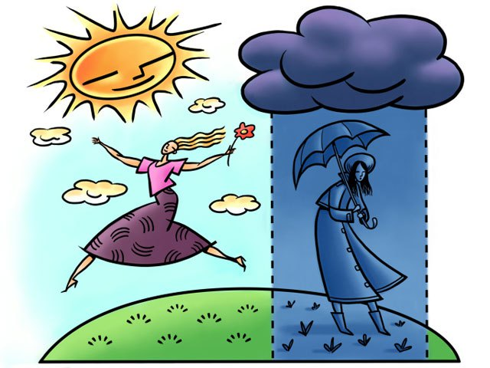

Seasonal Affective Disorder
Seasonal affective disorder (SAD) is a type of depression that comes and goes with the seasons. Symptoms of depression typically occur when summer transitions to fall and ends during the spring and summer months.
SAD is more common among women, young people and those who reside farthest from the equator. The causes of SAD are unknown though researchers have identified that people with SAD may also have an imbalance of serotonin, a brain chemical that can affect mood. Higher levels of melatonin, a hormone that regulates sleep can often be found in those who have SAD and some people with SAD may not have enough vitamin D.
While symptoms can vary from person to person, here are some common SAD symptoms.
Common SAD Symptoms:
- Consistently feeling sad or down, worthless, and irritable
- Feeling guilty or low self-esteem
- Oversleeping or difficulty sleeping
- Difficulty of staying awake
- Irritable
- Avoiding social contact
- Unable to handle stress
- Overeating, carbohydrate cravings and weight gain
- Loss of interest or pleasure in activities you use to enjoy
- Lower energy than normal
- Thoughts of death or suicide

Managing Seasonal Affective Disorder
There are several ways to treat SAD; prescribed medication which would require an individual to see their physician, cognitive behavioral therapy, which would be administered by a licensed therapist and light therapy.
Light therapy, commonly known as phototherapy, has shown to have favorable results for people with SAD.
Light therapy involves the use of a device known as a light therapy box. The light therapy box releases high concentrations of bright, artificial light that can substitute for natural light. This helps people with SAD to obtain the needed amount of natural lighting they need to return to symptom-free living.
Using light therapy is painless and easy. Sitting in front of a light therapy box daily will help you gain the proper amount of exposure to artificial lighting. The amount of time one will sit in front of the lighting may differ from one person to another and can be established by your own medical team based on your own needs.
Not all individuals will react positively to light therapy and may require medication therapy or counseling. Some people will find that the use of all three options is beneficial. To determine what is best for you, seek professional advice from your medical team.
When possible, use these techniques to help manage or prevent SAD.
- Get plenty of sleep, it will help to energize you for the next day
- Go out in the sunlight even in the winter months, it will help brighten your mood
- Exercise daily following your medical team’s recommended plan
- Stay connected with loved ones, they can be your support system
How to Know When to Involve My Medical Team?
Changes in the season can be challenging for many and can cause one to feel unmotivated, tired and even decrease energy levels. Involving your medical team in the management of your symptoms is always a positive step toward becoming the best health care advocate for yourself. When your symptoms begin to interrupt your daily routine, activities or start to change the way you feel about being social and active, it is important that you contact a member of your medical team to sit down and have a conversation about how you are feeling. Changes in eating habits, sleeping patterns and if you are seeing that your moods are not as balanced as they normally are can also be signals that you need to seek medical and professional assistance to effectively manage your symptoms. Any form of substance use or addictive behaviors is also an indication that you want to alert your medical team that you need immediate help.
Taking Positive Steps toward a Healthier You
Taking an active approach to a healthier you is always a great idea! Recognizing that your symptoms are more than just the “winter blues” means taking control of the situation and allowing your medical team to be there for you to help make the best decision for your situation. Getting as much natural sunlight as possible even on those cold winter days is beneficial. Daily exercise will help keep your body moving and your mind healthy. Establishing a regular sleep schedule will enable you to get enough rest every day and to awake feeling refreshed and ready to enjoy the new day. Being mindful and present every day and looking for the good in situations will also help to frame life in a positive light. Using relaxation breathing techniques can help keep you feeling relaxed and provide you with coping skills for managing stressful situations in your life. Step by step you can move toward a healthier you by being educated and informed about SAD and how it effects your life.

