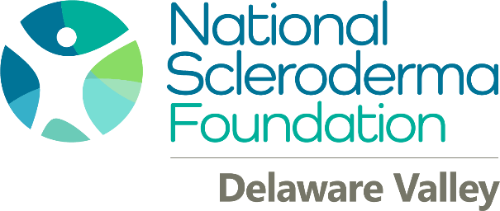

2022 Stepping Out To Cure Scleroderma WalkS

22nd Annual Shore Walk
Allaire State Park Farmingdale, NJ
June 5, 2022
www.scleroderma.org/allairewalk
SCLERODERMA is a chronic, degenerative autoimmune disease affecting approximately 300,000 people in the United States alone. The disease is characterized by an over-production of collagen causing thickening of the skin and loss of elasticity. Skin changes are the most visual effects of scleroderma, but the vital organs can also be affected resulting in pulmonary arterial hypertension, kidney failure, digestive disorders, cardiac arrhythmias, profound fatigue and pain, extreme sensitivity to cold temperatures, and loss of fingers or toes due to vascular damage. Scleroderma is a painful, life-altering disease that can be fatal. More information can be obtained at www.scleroderma.org.

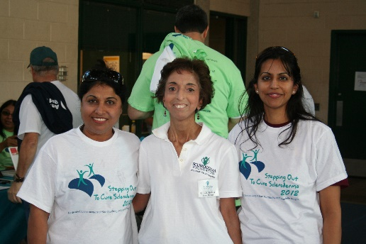
Families Walk to Raise
Scleroderma Awareness

Please consider becoming a WALK Sponsor In 2022

We will promote your company through our many scleroderma community networks including our website, newsletters, Facebook and fundraising events. Participating in a community charity event will enhance your public profile and you and your employees will feel a sense of pride in contributing to finding a cure for this debilitating disease. Your contribution may also be tax-deductible.

The National Scleroderma Foundation Delaware Valley Chapter is a nonprofit 501(c)3 organization committed to supporting the scleroderma community.

The mission of the National Scleroderma Foundation is to advance medical research, promote disease awareness, and provide support and education to people with scleroderma, their families and support networks.
For more information contact the National Scleroderma Foundation at 866-675-5545 or by email at DVchapter@scleroderma.org

